Learning Summary Report

**Jai Lafferty – 101610772**

# Overview

The custom application I created was a means of allowing users to save albums from the iTunes Search API to Core Data before being tested on which of the saved albums contains a given track. Users are also encouraged to browse the Wikipedia Page for each album as they are provided with a link which searches and retrieves the most relevant Wikipedia page to the Album’s title.

# Evidence

I have completed the following assignments and the evidence is presented as part of the portfolio pieces.

* All Pass Tasks
* All Credit Tasks
* All Distinction Tasks
* All HD Tasks

# Learning Summary

## Principles

Task 1 strongly encapsulates my understanding of mobile computing and design while directly evaluating the apps ‘Lost on Campus’ and ‘Genius’. Having completed Software Development For Mobile Devices this was familiar to me as a large portion of that unit was understanding the principles of mobile computing and design with respect to Android. I highlighted my knowledge of the limitations of mobile devices with task 1 with respect to network connectivity, processing power, screen size and the interruptible nature of the device.

## Development

The tasks 5-7 display my ability to develop simple mobile applications, the tasks built upon each other to eventually become my final distinction project. Again, given experience with the previous mobile development unit, I found that many of the development elements (including the MVC pattern) were relatively simple to carry over into iOS. This allowed me to build apps such as the quiz app in task 3 with relative ease as most of the core concepts had already been covered for me.

## Data

Task 7 and the distinction task were key example of the use of data within iOS. The idea of heavily using data was new as previously I had only dealt with file-based storage on Android. Task 7 displayed my ability to read and write from Core Data with relative ease. This was given data stored in memory (Codable classes and Structs). I had previously created another app (task 5) which allowed me to store data from an API into memory. The distinction app was where I tasks 5 and 7 to allow album data to be parsed from API to Memory to Core Data for persistent storage. While wrestling with APIs tended to be the fiddlier part, overall this was quite an easy process.

## Learning

This entire semester has had me learning a rapidly-changing development framework. Within the 12 weeks of learning Swift and entire new version has been released which, should I continue iOS development, means brand new content to learn. I have documented this learning in tasks 8 and 9 where I discuss different sources and their usefulness whilst creating a blog post to guide users through Relationships in Core Data. While the tasks display this learning, the most learning has been had again in tasks 7C and the distinction app where many new concepts had to be merged and different libraries and frameworks needed to be learnt.

# Challenges in Mobile Development

The most obvious challenge with mobile development is the number of different devices you are catering for. I found getting the layouts working correctly between different sized UIs quite challenging as some simpler UIs had to be expanded to make use of the extra space given by the larger devices. I particularly found this challenging when developing my Distinction app which was designed for an iPhone XS whereas my device was an iPhone 7, without the correct constraints I found the app breaking constantly during testing on a physical device as the screen sizes were different.

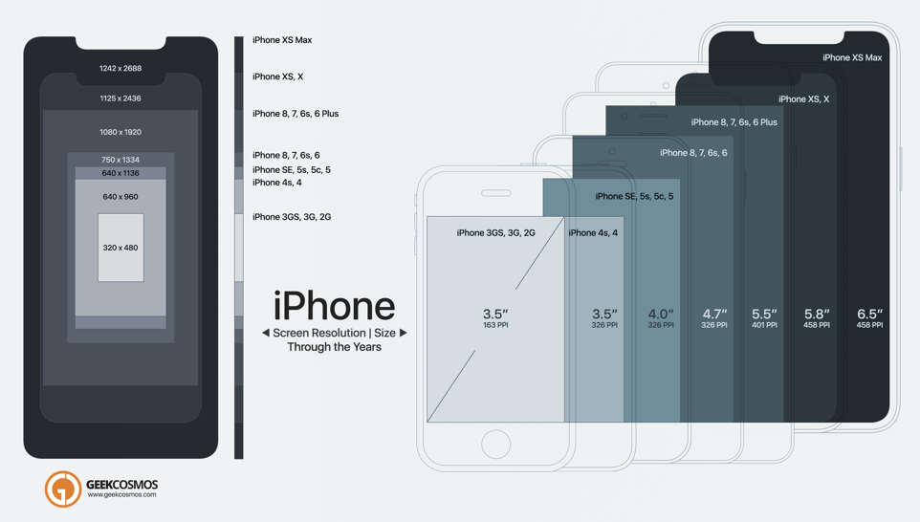

*iPhone XS, XS Max To 2G: Evolution Of Screen Size & Resolution[1]*

Another challenge would be keeping the users informed. As a developer I found I had to be considerate of how long actions take as mobile users have a notoriously short attention span. Things such as alerts and activity indicators were needed to highlight to the user that progress is made or why a feature isn’t behaving as expected. This took a surprising amount of time to implement for all features my Distinction app offered.

# Assumptions and Expectations

Again, I was lucky to be coming straight from the Android unit so as far as mobile development was concerned my expectations were met. Both platforms share concerns such as processing power, access via different devices etc, but I came into this unit with the expectation that iOS development was going to be more tedious and more restricted in some cases. This was met when I had code signing issues right away with Xcode not allowing my app to even be built until I deleted all local certificates from my keychain and starting again, in addition to my app not being allowed to run locally without an internet connection as my device could not verify the developer. It was small frustrating things like those which made me miss the wild west of Android where anything goes. I also expected that a lot of the tools necessary for iOS development would be more refined and easier to work with. I found this very true when implementing Core Data, I didn’t expect it to be so easy. As for the rest of the actual developing experience it was much on par with Android Studio in terms of features, but without the crashing and slow Gradle builds that come with Android Studio.

# Explorations

For my IoT Programming unit undertaken this semester I had to learn about networking and HTTP requests and APIs so I found this unit quite in line with the content. I decided to implement an app to send POST requests to a webserver hosted on a raspberry pi with an external IP Address. I found this very similar to how we tackled external data within this unit, and it was a breeze to get the simple app up and running.

In the future I would like to create some sort of metronome app as I have never found one that has all the features I want out of a metronome. Very brief research previously has led me to the fact that I need some sort of library to handle the timings on a background thread. I think this would be too hard to implement given proper research.

# Final Words

The main takeaway is the understanding of how a lot of the data driven apps on my phone operate. This unit has furthered my learning in mobile development, an area I am now quite interested in. It has also been good to see the other side of the mobile coin and being able to compare and contrast my own understanding of Android development with iOS development and where they both excel.

1. Khan S 2018 <https://www.geekcosmos.com/iphone-xs-max-2g-screen-size-resolution-comparison-infographic/>